**Definition: Build reusable components of a vector in Figma.**

**Solution:**

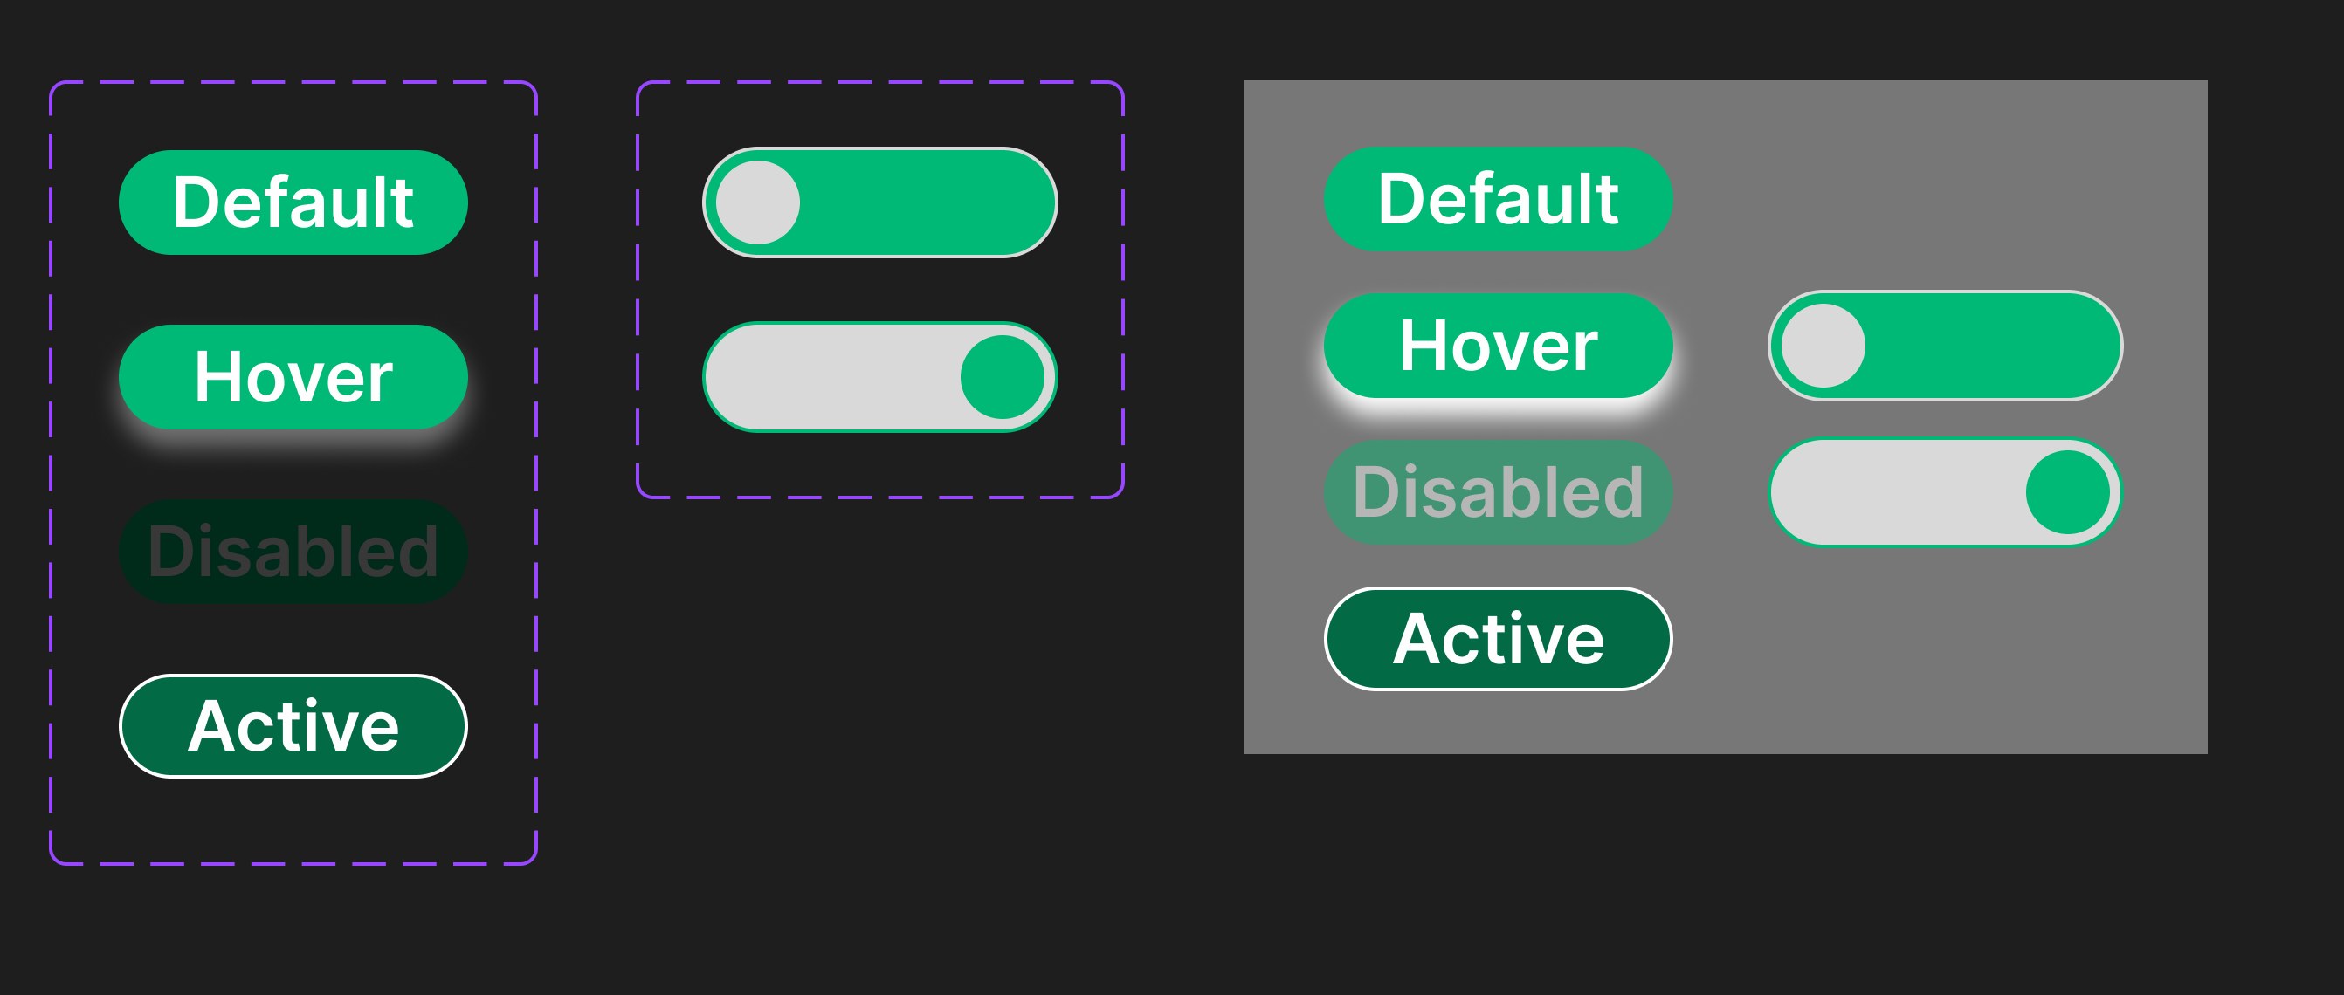

**Steps:**

* First Open Figma in browser mode.
* Then create the new document **File à New Figma Design.**
* Now to make reusable button we must make variant types of buttons.
* **Button:**
  + First to make **“Default”** take a rectangle of width=”**100 px”**, height=”**30 px”** and color=**”#026A45”**, radius**=”20”.**
  + Now to make **“Hover”** take copy of above rectangle and give color**=”#00B976”** and give effect=**”Drop Shadow”** and shadow Blur=**”8”.**
  + Now to make **“Disable”** take copy of above rectangle and give color**=”#00B976”** and layer**=”SoftLight”.**
  + Now to make “**Active**” take copy of above rectangle and give stroke=**”1 px”**, stroke color=**”#FFFFFF”.**
  + Select all four rectangles then press **“Ctrl + Alt + k**” to make component.
* **Switch:**
  + Now to make “OFF-Switch” take a rectangle of width=”**100 px”**, height=”**30 px”** and color=**”#00B976”**, radius**=”20”** and give stroke=**”1 px”**, stroke color=**”#FFFFFF”.**
  + Inside the rectangle place ellipse of width=”**24 px”**, height=”**24 px”** and color=**”#FFFFFF”** on the left side**.**
  + Now to make “ON-Switch” take a rectangle of width=”**100 px”**, height=”**30 px”** and color=**”#FFFFFF”**, radius**=”20”** and give stroke=**”1 px”**, stroke color=**”#00B976”.**
  + Inside the rectangle place ellipse of width=”**24 px”**, height=”**24 px”** and color=**”#00B976”** on the right side**.**
  + Select Both rectangles then press **“Ctrl + Alt + k**” to make component.
* Now you can use variant of Button and Switch from assets in your Figma file.
* Now, Go to the **Export** button in the property panel. And **Export** it with .**JPG/.PNG** format.